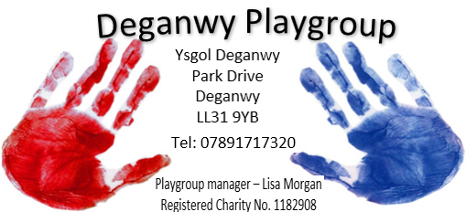

Quality of care
annual report
2025/26.

Introduction
Deganwy Playgroup is a long-established and continually developing playgroup, providing a warm, welcoming and nurturing environment for young children. We are an English-speaking setting and provide children with a fun and engaging introduction to the Welsh language.
Set within a spacious, bright and airy facility adjacent to Ysgol Deganwy, our playgroup offers children a safe and stimulating environment where they can learn, explore, develop new skills and build confidence, helping to make the transition into primary school a happy and positive experience.
We welcome children from their second birthday until they reach full-time school age. Through our Playgroup and Playgroup Plus sessions, children can learn, develop and have fun with us as they prepare to start full-time school in the reception class of their chosen primary school.

A Caring and Experienced Team
As a Charitable Trust, Deganwy Playgroup is managed by a voluntary Management Committee of Trustees, made up of elected parents, grandparents and carers of children who currently attend, or have previously attended, the playgroup.
The Committee and Manager employ a dedicated and highly qualified team of staff who, between them, have decades of experience and many years of service within the playgroup. Our staff and Management Committee take great pride in the high-quality provision we offer, and our reputation within the local community has been built through years of commitment, care and dedication to the children and families we support.

Learning Through Play
Our setting delivers the Curriculum for Wales, introducing children to this approach from the age of three, before they begin nursery school.
We also provide funded education for three-year-olds who, because of their date of birth, may miss the cut-off date for a nursery place at school.
Through a balance of child-led play and carefully planned activities, we encourage children to develop their independence, confidence, communication, social skills and curiosity, while learning at their own pace in a fun and supportive environment.

Playgroup Plus
We also offer Playgroup Plus sessions, providing two wrap-around care sessions in conjunction with the Dosbarth Meithrin/Nursery Class at Ysgol Deganwy.
Children can be dropped off with us from 8.45am and remain in our care until 1.00pm. At 1.00pm, children attending Ysgol Deganwy are collected from the playgroup by their teacher or teaching assistant and taken to their class, where they are signed in by the school staff.
Alternatively, children attending the school nursery can be collected from their teacher or teaching assistant at the school door at 11.00am. We then care for them at the playgroup until 2.45pm, when they can either be collected by a parent or guardian or signed over to Deganwy Out of School Club.
At Deganwy Playgroup, we are proud to provide a friendly, caring and stimulating environment where children can learn, play, grow and prepare for their next big step into school.
Playgroup
Children, Learning and Development
We started the year with a high number of children attending both our Playgroup and Playgroup Plus sessions. We even had a waiting list and were operating to full capacity during our lunchtime sessions. This reflected the continued demand for the provision we offer within the local community.

Flying Start
We received monthly visits from Lauren, our Flying Start Liaison, who observed children’s play, learning and development within the setting.
All children accessing Flying Start funding were assessed for speech and language development using Flying Start’s WellComm documentation. These assessments were collected termly by Lauren and returned to us with identified next steps to support each child's development.
Throughout the year, we also recorded observations and collected photographic evidence of children's learning and play. This information was used to contribute to each child's Flying Start Learning and Development Record. These records were shared with parents approximately two to three times during the year, depending on when their child started at playgroup, and were also shared with the child's school at the end of the academic year.
This year, we had a particularly high number of children accessing Flying Start funding following the expansion of the Flying Start catchment area across the whole of Conwy. Of the children attending our setting, only three families were paying independently, as they were accessing funded provision at another setting.

Curriculum for Wales and Assessment
Within Playgroup, we deliver the Curriculum for Wales to eligible three-year-old funded children. Our approach to assessment is based on regular observation, allowing us to remain flexible and responsive to each child's individual interests, needs and development.
All staff have their own observation notebooks and are encouraged to observe children's learning, play and interactions with both their peers and staff members. These notebooks are collected by the Manager approximately once a month. The Manager/Playleader then transfers the relevant observations onto digital observation sheets, which are stored within each child's individual file.
This information is used to monitor children's progress and, once each term, parents are emailed copies of their child's observation sheets alongside photographs showing their child engaged in play and learning.
All Playgroup children also have a digital assessment booklet using the template provided by Early Years. This includes two key points of assessment: an initial assessment at the beginning of their funded period and a further assessment at the end of the academic year.
Although these assessment booklets are particularly relevant to our funded three-year-olds, we have chosen to use the same approach with all children attending Playgroup. This provides us with a consistent and effective way of recording children's progress, celebrating their achievements and capturing their wow moments, regardless of whether they are accessing funded provision.
The more regular sharing of observations, photographs and information about children's progress with parents has been extremely successful. Parents have responded very positively, with many commenting on how much they value receiving regular updates about their child's learning and development.

Learning Through Play
As our understanding and implementation of the Curriculum for Wales has developed, we have reduced the number of adult-led and focused activities and placed a greater emphasis on learning through play.
We have increased opportunities for open-ended, uninterrupted play, allowing children the time and freedom to explore, experiment, problem-solve and develop their own ideas. We have continued to replenish and add to our stock of loose parts, while also adapting and repurposing equipment and resources we already have. This has enabled us to provide more open-ended experiences that encourage children's creativity, independence, learning and development.
We have worked particularly hard to follow children's interests and respond to their individual interests, ideas and requests for particular equipment or resources. By following the children's lead, we have been able to create meaningful learning opportunities that are engaging and relevant to them.

Supporting Different Ages and Needs
This year, we continued to separate the Playgroup and Playgroup Plus children during registration periods when appropriate. However, we recognised that children's individual needs did not always correspond with their age.
Some younger children were keen to spend time with the older children, while some of our quieter older children were more comfortable and confident within the smaller Playgroup group.
To respond to this, we were flexible in how we organised the children, dividing them into two smaller groups based on their individual needs, friendships, confidence and emotional wellbeing rather than simply their age.
This approach worked particularly well. The smaller groups provided children with greater opportunities to engage, communicate and participate confidently, while still allowing us to respond to their individual preferences and needs.

Speech, Language and Communication
With support from Lisa Davis through the Early Years Speech and Language Initiative, Laura became our setting's Language Pioneer.
Laura developed and shared a range of speech and language activities with families through email and Facebook, as well as incorporating activities directly into our Playgroup sessions. She drew inspiration from resources such as the BBC's Tiny Happy People and introduced a different language development skill each half term.
Activities included bubble-blowing exercises to support the development of mouth shapes and sounds, particularly for sounds such as P and B. With our older children, we introduced clapping syllables in their names, helping them to recognise and break longer words down into smaller parts.
Laura also developed a range of themed language baskets, providing children with opportunities to develop their communication and language skills through topics that interested and engaged them. Themes included:
- Diwali
- Pirates
- Colours
- Christmas
- Easter
- Circus
These resources provided valuable opportunities for children to develop their vocabulary, listening skills, confidence and ability to communicate through play.

Speech and Language Therapy Support
We also received support from Speech and Language Therapy (SALT) for two children within the setting.
One child was supported remotely through the sharing of relevant documents, resources and guidance, while another child received direct support from a member of the SALT team who visited the setting.
We worked closely with the professionals involved to ensure that strategies and recommendations could be incorporated into the child's everyday experiences within the setting. This collaborative approach enabled us to provide consistent support and promote children's communication and language development as part of their daily play and learning.

Playgroup Plus
Playgroup Plus had a very positive start to the year, with 11–13 children attending each morning and numbers increasing to 17–19 children during our busier afternoon sessions. Of these, approximately four children were Playgroup children who were able to access extended wrap-around care.
Typically, numbers within Playgroup Plus build steadily throughout the year. However, due to the particularly high demand this year, some sessions reached full capacity, and we had waiting lists for certain lunchtime places.
Our wrap-around sessions continue to be a valuable service for local families. They provide additional flexibility for parents returning to work, while also offering parents the opportunity to gradually familiarise their nursery-age children with a longer day, preparing them for the transition to full-time school the following year.
We work closely in partnership with Ysgol Deganwy, whose teachers and support staff play an important role in helping us provide a smooth and consistent service for children attending both settings.
We are particularly fortunate that, due to our proximity to Ysgol Deganwy, the transition between the school's Nursery Class and Playgroup Plus can happen seamlessly. Children are collected or delivered by school staff and move between the two settings easily and confidently.

Welsh Government 30-Hour Childcare Offer
The continuation of the Welsh Government's 30-hour Childcare Offer was a significant benefit to the Playgroup financially this year. Parents who were eligible for the scheme were able to increase the number of sessions their children attended, while we also welcomed new children to Deganwy Playgroup through the offer.
We have always worked hard to keep our fees as affordable as possible for local families. As a result, eligible parents did not have to pay any additional top-up fees to the Playgroup, as their full fees were covered through the Childcare Offer.
The scheme has therefore been beneficial not only in supporting families with the cost of childcare, but also in helping us to maintain strong attendance and financial stability while continuing to provide accessible, high-quality childcare within our local community.

The Employed Staff and the Voluntary Committee of trustees

Staffing and Team Development
Deganwy Playgroup is fortunate to have a highly committed and dedicated team of permanent staff who work well together and care deeply about the Playgroup, the children and families we support, and the quality of provision we provide.
Staff continually develop their knowledge and skills and are encouraged to take responsibility for their own professional development. They are supported in their roles by both the Manager and members of the Management Committee. Staff receive a formal appraisal at least annually, alongside more regular staff review meetings, providing opportunities to discuss progress, training needs, wellbeing and any additional support required.

Voluntary Management Committee and Trustees
The Playgroup continues to benefit from the support and commitment of its voluntary Management Committee of Trustees. This year, our Chair re-stood for the position, our Treasurer re-stood and our secretary was also happy to remain. We welcomed a new Committee member, while 2 existing members continued in their role.
All members of staff are also Trustees, providing valuable insight and ensuring that the management and governance of the Playgroup remain closely connected to the day-to-day experiences of the children, families and staff.
The Committee meets formally three times each year, alongside an Annual General Meeting, with additional meetings held when required to discuss staffing, operational matters and the ongoing development of the Playgroup.

Staff Changes and Development
This year has seen a significant amount of change within the staff team. Although this has presented some challenges, it has also provided valuable opportunities to strengthen our management structure, develop staff and welcome new members to the team.
We were delighted to welcome Rosie to the setting to fill one of the two vacancies that had remained open following the previous year. Rosie relocated to North Wales from the Midlands and has settled into the Playgroup extremely well. She has quickly become a valued member of the team and has been particularly supportive in helping children settle into Playgroup.

Strengthening the Management Structure
Early in the year, Emily, who had been working as Playleader, requested to step back into a Playworker role to support a better work-life balance. Unfortunately, there was not a Playworker position available at that time. Following consultation with our HR providers, Chair, manager and Emily, we were able to offer Emily a move back into a supervisor role.
At the same time, Nerys, who had been Lead Supervisor and had also been providing Acting Leader cover in Emily’s absence, was supported to take on greater leadership responsibilities.
These changes prompted the Manager and Trustees to review our existing management structure and consider how we could strengthen the leadership and management tiers within the organisation. As a result, we created a new Deputy Manager position.
Nerys successfully interviewed for the role and has taken up the position. As Deputy Manager, she will work closely alongside Manager Lisa and has also become registered with Care Inspectorate Wales (CIW) as a Person in Charge. Nerys began settling into her new role in April 2026 and has embraced the additional responsibilities very positively.
The introduction of the Deputy Manager role has strengthened our leadership structure, provided greater management support and created improved continuity when the Manager is absent.

Further Changes to the Staff Team
Later in the year, Emily informed the Manager and Trustees that she had successfully applied for training as a midwife with the NHS and had decided to leave her permanent position to pursue this career opportunity in June. We were pleased that Emily wished to remain part of the Playgroup as a member of our bank staff, allowing us to retain her experience and knowledge within the setting and providing additional cover when required.
Following this, all our Level 3 qualified staff were offered the opportunity to apply for Supervisor positions, either individually or as part of a shared role.
Three of our Level 3 practitioners — Sara, Laura and Rachael — expressed an interest in sharing the Supervisor role. The process was managed in consultation with our HR provider and included formal interviews and the introduction of new contracts.
A settling-in period took place during June and July, with the new arrangements formally commencing from September 2026. This has provided additional opportunities for leadership development within the existing staff team while strengthening our supervisory structure.

Recruitment and New Staff
A member of staff who joined us in November unfortunately did not successfully complete their extended probationary period. Following discussion and support, it became clear that the setting was not the right fit for them, and their employment came to an end.
We subsequently advertised for a new member of staff. During the recruitment period, existing staff worked flexibly to cover the hours required, supported by our bank and supply staff when necessary.
We were pleased to appoint Nichola, who successfully interviewed for our Level 3 position and joined the team in June 2026. Known as Nic, she brings a wealth of valuable experience to the setting, having previously worked as a childminder. She is also a First Responder volunteer and has quickly become a valued addition to the team.

Supporting Staff Development and Future Planning
Laura informed the Manager that she had applied for a university place to pursue her interest in Speech and Language. At the time, it was uncertain whether she would be offered a place, which meant that this had the potential to affect our staffing arrangements.
Although Laura initially believed that she had not secured a place, she was offered a place part-way through the summer holidays. She subsequently handed in her notice, with her final date in September 2026, and asked to remain on our bank staff team.
The Manager and Trustees have been working proactively to recruit a replacement as soon as possible. In the meantime, existing staff and bank staff have offered additional hours to ensure that the required staffing levels can be maintained while recruitment takes place.

Looking Forward
It has undoubtedly been a year of significant staff change for Deganwy Playgroup. However, these changes have also brought many positive opportunities. We have welcomed new members of staff who have settled well into Playgroup life and have brought new skills, experience and enthusiasm to the team.
We are particularly pleased that both Emily and Laura have chosen to remain connected to the Playgroup as bank staff. This means that their experience and knowledge remain available to support the setting when additional cover is required, while also providing continuity and familiarity for the children and wider staff team.
The changes made this year have also enabled us to strengthen our management structure, improve our induction and settling-in processes, and place a greater emphasis on staff wellbeing and support.
Despite the challenges associated with a period of significant staff turnover, the team has remained committed, flexible and supportive of one another. We are confident that the strengthened management structure and the development of our staff team will provide a strong foundation for the continued growth and development of Deganwy Playgroup.

Grants
For the big summer grant Playgroup applied for resurfacing and extending the soft impact surface in the garden. This benefited not only playgroup, But all users of the building. The work was completed in January and has been very gratefully received by all uses especially for the children as the team who installed the soft surface were able to add additional pathways to the house and mud kitchen within our quote.

Staffing qualifications and training

Current Staffing Structure
Our current staffing structure is as follows:
Role | Staff Member | Qualification
Manager | Lisa | Level 4 + ILM Level 5
Deputy manager | Nerys | Level 3
Playworker | Laura | Level 3
Admin & Playworker | Jo B | Level 2
Playworker | Angela | Level 2
Playworker | Rachael | Level 3
Playworker | Sara | Level 3
Playworker | Rosie | Level 3
Playworker | Nichola | Level 3
Bank Playworker | Emily  Jo L | Level 3  Level 2
  Bank Playworker
As part of her new Deputy Manager responsibilities, Nerys will be supported to work towards further management qualifications at Levels 4 and 5, helping to strengthen her professional development and the leadership capacity within the setting.

Training and Professional Development
Staff continue to undertake all required mandatory training and complete refresher training when due. During the year, this has included areas such as:
- Fire Safety
- Manual Handling
- Health and Safety
- Risk Assessment
- Food Safety Level 2
- Paediatric First Aid
- Infection Prevention and Control
- Safeguarding
All staff have completed the new comprehensive Safeguarding training, ensuring that the whole team remains up to date with current safeguarding procedures, responsibilities and best practice.
All new members of staff appointed during the year have also completed the appropriate enhanced DBS checks before working with children, in line with our safeguarding requirements.
We remain committed to ensuring that staff have access to appropriate training and development opportunities, enabling them to maintain their professional knowledge, develop their skills and continue to provide high-quality care, learning and support for the children attending Deganwy Playgroup.

Funding and Fees
Deganwy Playgroup receives funding for eligible children through the Three-Year-Old Funded Education scheme and the Welsh Government's 30-Hour Childcare Offer. This year also marked the setting's first full year operating as a Flying Start setting, providing funded places for children who meet the relevant eligibility criteria.
As part of our financial planning for the coming year and beyond, the Chair, Administrator and Manager carried out a detailed review of the Playgroup's budget and projected costs. This review considered the continued rise in operating costs, including an increase in our rent.
Following consideration of the financial position, the Committee Chair and Trustees agreed that an increase in our fees was necessary. The revised fees will bring our charges in line with the current funded rates and will help ensure that the Playgroup remains financially sustainable while continuing to provide a high-quality, accessible service for children and families within our community.
The Trustees remain committed to keeping the Playgroup financially responsible while ensuring that fees remain as fair and affordable as possible for local families.

Education and Resources
Children are supported through the Curriculum for Wales, using the Early Years templates and guidance for observation, assessment and baseline information. We use observation sheets, assessment booklets and the appropriate baseline documentation to monitor and support each child’s progress and development.
All Playgroup children, whether accessing Three-Year-Old Funded Education or Flying Start, receive termly emails containing observations and photographs of their child engaged in a range of activities and experiences. Children’s progress is also recorded through the Early Years Assessment Booklet and/or Flying Start Learning and Development records, as appropriate. These assessments provide points of entry at the beginning of the three-year funding period and at the end of the academic year.
As highlighted elsewhere in this report, parents have responded very positively to the increased frequency of feedback and the opportunity to see photographs and examples of their child’s learning and experiences.
Parents of Playgroup Plus children have also received termly photographs showing what their child has been doing and enjoying during their sessions, together with two reviews throughout the 2025–2026 academic year.

Supporting Individual Learning and Development
Staff support each child’s individual learning needs by adapting play and learning opportunities to reflect their stage of development, interests and abilities. Children are offered plenty of choice during group sessions, and this year we have particularly observed how much they enjoy using open-ended loose parts creatively in art, role play and outdoor free play.
Children are supported with their individual next steps, helping to promote continued learning and development. We have also shared language-development activities and ideas with parents through our Facebook page. These have received very positive feedback, with several parents reporting that they have used the activities and ideas at home.

Resources and Learning Opportunities
The Playgroup regularly invests in new equipment and resources to ensure that children have access to a broad and varied range of learning opportunities, while also ensuring that staff have the resources, they need to support high-quality practice.
We continue to incorporate natural and recycled materials into children's play, using items such as shells, pinecones, sheep-wool packaging, herbs, fruit and vegetables to enrich sensory, creative and imaginative experiences.
This year, we also received additional resources through the Flying Start programme, following staff attendance at fairs and training events. These included large puppets, books and wooden equipment to enhance our role-play kitchen and malleable play areas. We also received a range of Forest School resources to support learning, exploration and discovery within our outdoor environment.

Woodwork Project
This year, we introduced a small woodwork project with support from our Committee Chair. He with staff, supported the children to use child-friendly tools to hand-drill and saw small pieces of wood.
Children were introduced to simple woodworking skills through close, one-to-one adult support. This provided opportunities to develop concentration, coordination, fine and gross motor skills, confidence and an understanding of how tools can be used safely.

Snack and Healthy Eating
Snack is provided solely by the setting, with full consideration given to children's allergies, intolerances and dietary requirements.
We operate a rolling snack time, allowing children to choose when they would like to have their snack so that their play and learning are not unnecessarily interrupted. Snack menus are regularly reviewed and updated to reflect children's preferences, seasonal produce and current topics and themes.
All snacks are balanced and follow healthy eating guidelines, and every child is offered a drink of milk or water during snack time.
For children staying for lunch, meals are served on plates and children sit at tables with a member of staff, who eats alongside them and provides support and assistance where needed. We also encourage children to develop an awareness of recycling and reducing food waste following lunch. Staff on kitchen duty return any uneaten food to children's lunch bags or boxes so that parents can see what their child has eaten.
Parents have been reminded that Deganwy Playgroup is a nut-free setting, as both staff and children have nut allergies. We take appropriate precautions to minimise the risk of cross-contamination and ensure that children with allergies or intolerances are not seated next to others who may have food items that could cause a reaction.

Developing the Setting
Throughout the year, we have continued to work on identified targets to develop and improve our environment, resources and provision. We have focused particularly on increasing opportunities for Welsh language development, improving our outdoor environment and expanding children's opportunities for outdoor and Forest School-style learning.

Target 1: Developing Welsh Language Content
We have continued to develop the use of Welsh within the setting, making use of resources and guidance provided by our Early Years Advisor, including Welsh-language signage throughout the setting.
We have also made use of Twinkl resources to support Welsh language activities and experiences and have continued to explore opportunities to increase the use of Welsh within everyday play and routines.
The setting was offered Clebran training through Camau, which is due to commence in September 2026. This will provide further opportunities for staff to develop their confidence and ability to use Welsh naturally within the setting.
We have also been fortunate to have the support of Emily, our Playleader/supervisor, and Jack, our Committee Chair and volunteer, both of whom are experienced Welsh speakers. They have helped to introduce and model Welsh within the setting, encouraging both staff and children to hear and use more Welsh throughout the day.
We have also continued to use Welsh Language Flowers. These have been particularly useful in supporting staff to introduce simple Welsh words and phrases linked to the topics and themes that the children are interested in.
We have found that the Language Flowers work particularly well when topics are being explored regularly. However, as some themes are only revisited occasionally, we have identified that staff do not always retain the vocabulary and phrases as confidently as we would like. This is an area we will continue to develop, with a focus on repetition, revisiting vocabulary and building Welsh into everyday routines rather than relying solely on individual topics.

Target 2: Developing the Outdoor Environment
One of our key priorities was to improve the outdoor environment. The existing soft-play surface in the garden had begun to shrink and show signs of general wear and tear, so it required replacement.
We used funding from our Summer Grant to address this, and the new surface was completed and in use by February 2026.
The improvements have had a significant positive impact on the setting. Extending the new surface into pathways between the different play areas has been particularly beneficial. It has made the garden much more accessible in a wider range of weather conditions and has allowed children to move safely between different areas of the garden throughout the year.
This has been a real game changer for outdoor play, supporting greater use of the whole outdoor environment and providing children with more consistent opportunities to play and learn outside.

Target 3: Incorporating Forest School Activities
While the garden surface was being replaced, we were fortunate to have regular access to the school's larger grassed outdoor area. This gave us the opportunity to see first-hand how beneficial having access to a larger natural space could be for the children.
The additional space provided opportunities for children to:
- Run freely and develop their physical skills
- Kick and play with balls
- Explore climbing trees with appropriate adult support
- Build larger-scale dens
- Explore natural materials and their surroundings
- Take part in age-appropriate risky play
- Use their imagination and lead their own play
- Experience outdoor learning on a much larger scale
The children responded extremely positively to these opportunities. They were able to explore using all their senses, develop confidence and physical skills, take appropriate risks and work collaboratively with others.
Following the success of this, we worked with the Headteacher to arrange regular continued access to this larger outdoor area. This has enabled us to build on the children's interest in Forest School-style experiences and provide opportunities for outdoor learning that would not be possible within our own garden alone.
We have also received support from our Flying Start Liaison with ideas for outdoor activities, as well as guidance from our Early Years Advisor when developing our wish list for the year's Summer Grant funding and will be a target for the following year.

Target 4: Refreshing and Repainting the Outdoor Playhouse
We identified the outdoor Playhouse, along with the older Mud Kitchen area, as an area that would benefit from being refreshed and revitalised.
With the fantastic support of our Trustees and staff, we were able to repaint and enhance the Playhouse and older Mud Kitchen. Staff and Trustees generously gave their time, creativity and artistic skills to transform the areas and give them a new lease of life.
The Playgroup purchased the required painting equipment, while paint was generously donated by Crest.
The refreshed Playhouse and Mud Kitchen have created a more attractive and inviting area for the children and have helped us to make better use of existing resources rather than replacing them. This project also demonstrated the continued commitment of our staff, Trustees and wider community to improving the setting for the children who attend.

Provision of Information Sharing, Policies and Procedures
We place a strong emphasis on keeping parents and carers well informed and ensuring that they have regular access to information about their child's experiences, learning and development, as well as important information relating to the Playgroup.

Communication with Parents and Carers
Parents receive timely information from our proactive administrator, Jo, regarding fees, grants, applications and other non-educational matters. Jo ensures parents are kept informed about available funding opportunities and key application deadlines, while also providing essential administrative support to ensure the smooth day-to-day running of the setting.
Parents and carers receive regular 'What's On' newsletters, which provide information about current themes, upcoming events, activities and other important dates. These are emailed directly to families, alongside any additional information or updates that may be relevant.
As outlined elsewhere in this report, we have also increased the frequency and quality of information shared about children's individual learning and development. Parents receive regular emails containing observations, photographs and assessment information, including copies of assessment booklets.
For children accessing Flying Start, parents are also provided with relevant WellComm assessment information and Learning and Development records. For Playgroup children, these are shared at appropriate points throughout the year, while Playgroup Plus families receive termly updates where applicable.
This regular communication has been very positively received by parents and has helped strengthen the partnership between home and the setting. It gives parents a clearer insight into what their child has been doing, learning and enjoying while attending Deganwy Playgroup.

Website and Social Media
Our website is regularly reviewed and updated and acts as the formal source of information for the Playgroup. It provides families with access to our Parent Information Pack, Policies and Procedures, as well as information and links relating to:
- Three-Year-Old Funded Education
- The 30-Hour Childcare Offer
- Flying Start
- Other relevant information for families
The Playgroup Manager also updates the Deganwy Playgroup Facebook page, which has a good following among our parents and wider community. Our Facebook feed is also visible through the Playgroup website, providing another accessible way for families to keep up to date with news, activities and events. Updates weren’t as frequent as liked due to managers other commitment, so looking forward this could be shared with the new Deputy.

Policies and Procedures
The Playgroup Manager and trustees are responsible for the ongoing review and development of our Policies and Procedures, with support from the Administrator where required.
Policies are reviewed regularly to ensure that they remain current, relevant and reflective of changes in legislation, guidance and best practice. Where new requirements arise, new policies are introduced, and existing policies are amended and updated as necessary.
Parents and carers can access our policies through the website where they are available. Copies of any additional Policy or Procedure are also available to parents on request.

Fees Policy
During the year, a new Fees Policy was developed by the Committee Chair to provide a clear and consistent procedure for managing overdue payments.
The policy sets out the steps to be followed where fees remain outstanding and provides greater clarity for both the Playgroup and families. The policy was considered and approved by the Committee of Trustees before being shared with parents and carers.
This provides a transparent and consistent approach to fee collection while ensuring that families understand the procedures and expectations surrounding payments.

Feedback
Towards the end of each school year, questionnaires are distributed to parents to allow for parents to feed back their thoughts in a manner that can be standardised and measured. At around the same time and during a normal session, staff will ask simple questions to the children about what they think about Playgroup.
Below are some of the comments we received from the children:
Ernie: playing with friends is fun.
Ivy: I like colouring and Auntie Laura.
Oakley: I liked climbing the tree.
Phoebe: dressing up.

Parent survey results 2025/26
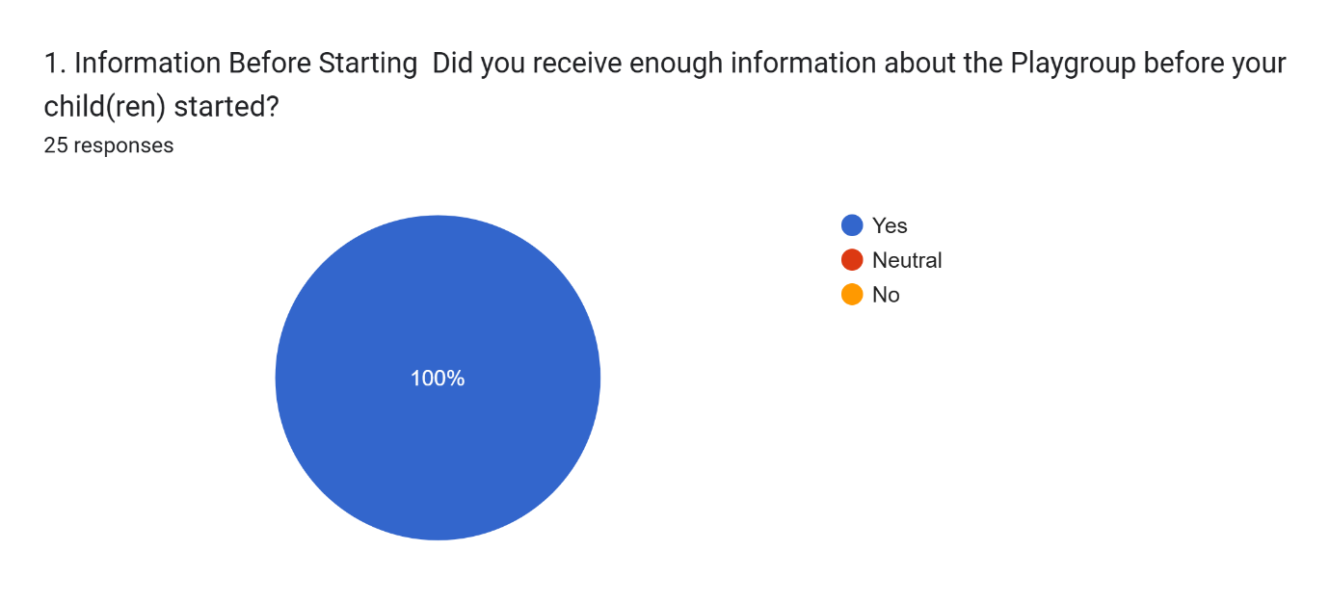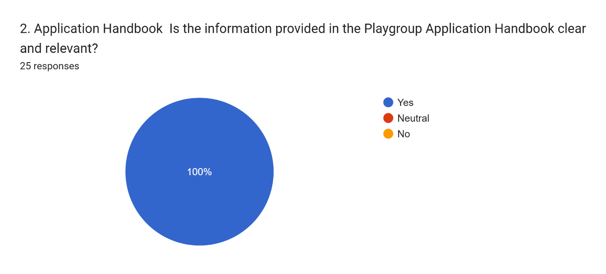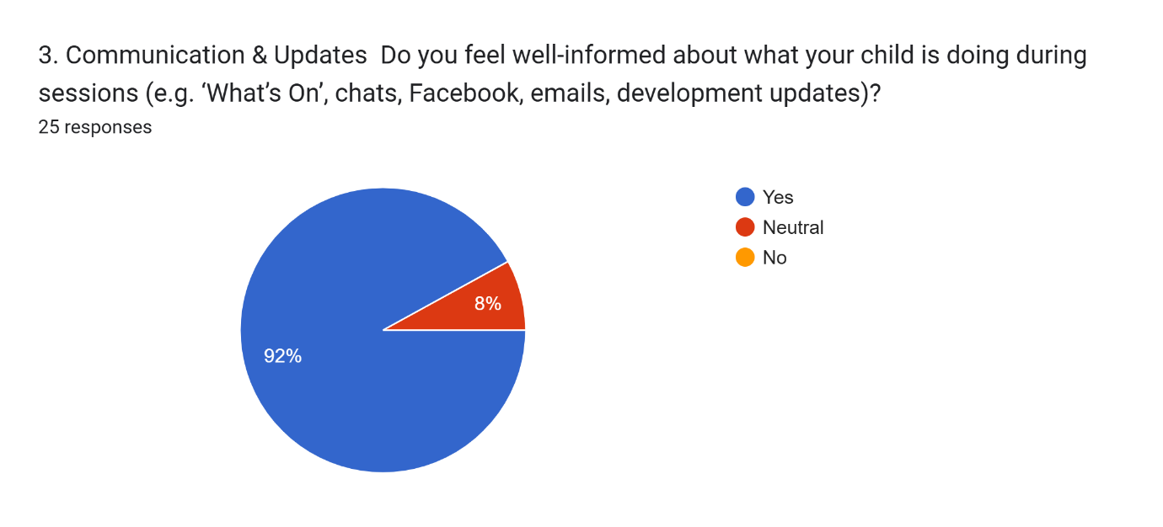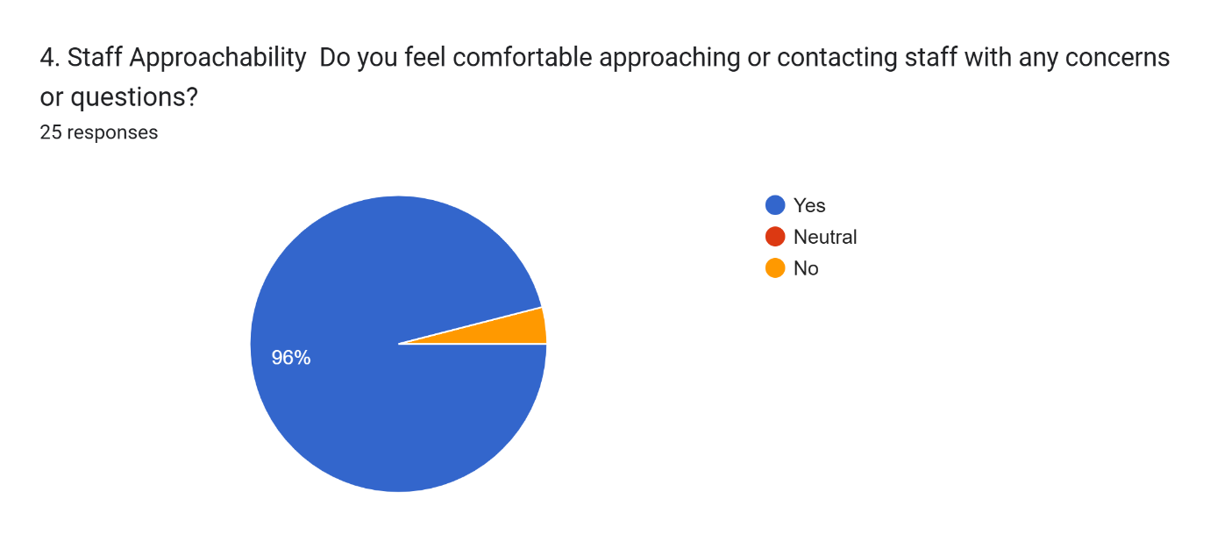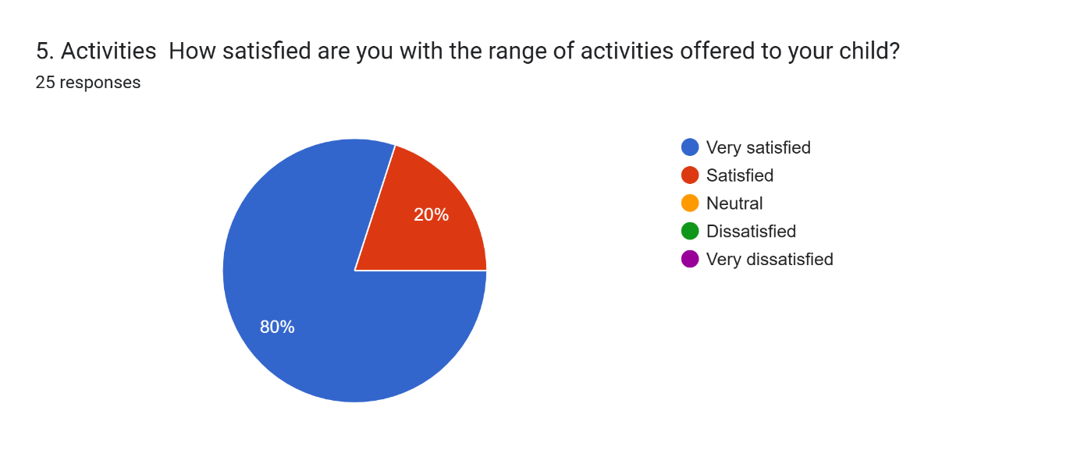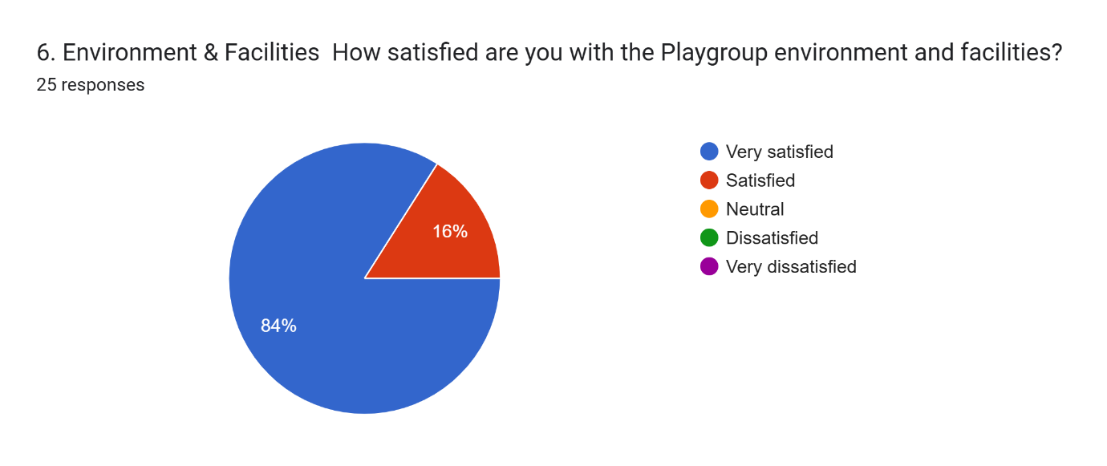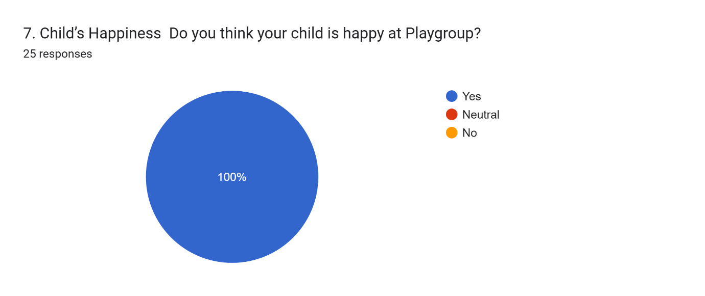8. Additional Comments
Additional comments or suggestions:
12 responses
Ada has settled wonderfully into playgroup so thank you very much. Staff are always so welcoming and engaging as soon as she walks through the door and she loves showing off the most recent doll that she has taken that day! The only feedback I would give is maybe implementing a process whereby any pictures /artwork that gets created is brought home that day where possible. Thanks to all and have a lovely summer!

There used to be more updates and photos on the Facebook page. It would be nice to have an app/system used like school does so we can see photos of them too

My son has always looked forward to coming to playgroup and genuinely had fun while being there. Thank you.

Deganwy playgroup remains outstanding for their kindness, care and attention to all children who attend. We have been delighted to know how safe our children are and are excited to attend for the past 3 years.

Thank you to all the aunties for all that you do

Both my children have been so happy attending playgroup. The Aunties are all lovely and I feel very safe leaving my children in their care. Thank you so much!

Lovely nutritious snacks, great activities, songs that introduce the Welsh language. You get parents involved. All fab, thank you so much

Excellent

Long sleeved aprons for painting for the extra messy children. Continue being fabulous my girl loves every day she spends here.
All the aunties are lovely

We cannot praise the lovely aunties at Deganwy Playgroup enough for their help and support over the last year.

The most amazing playgroup, we are truly gutted Robyn is finishing soon. She loves it so much. All of our girls have loved going! Thank you

